<<Interface>>

***Incrementable***



+ increment (): void



+getValue (): int



**RandomIncrementer SequentialIncrementer**



- rand : int -start : int

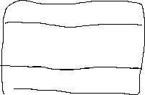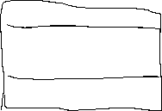

- rad : Random



+RandomIncrementer(): +SequentialIncrementer():